Matt Tranchina 05/07/2023

CS-230 Operating Platforms 1-4 UML Diagrams

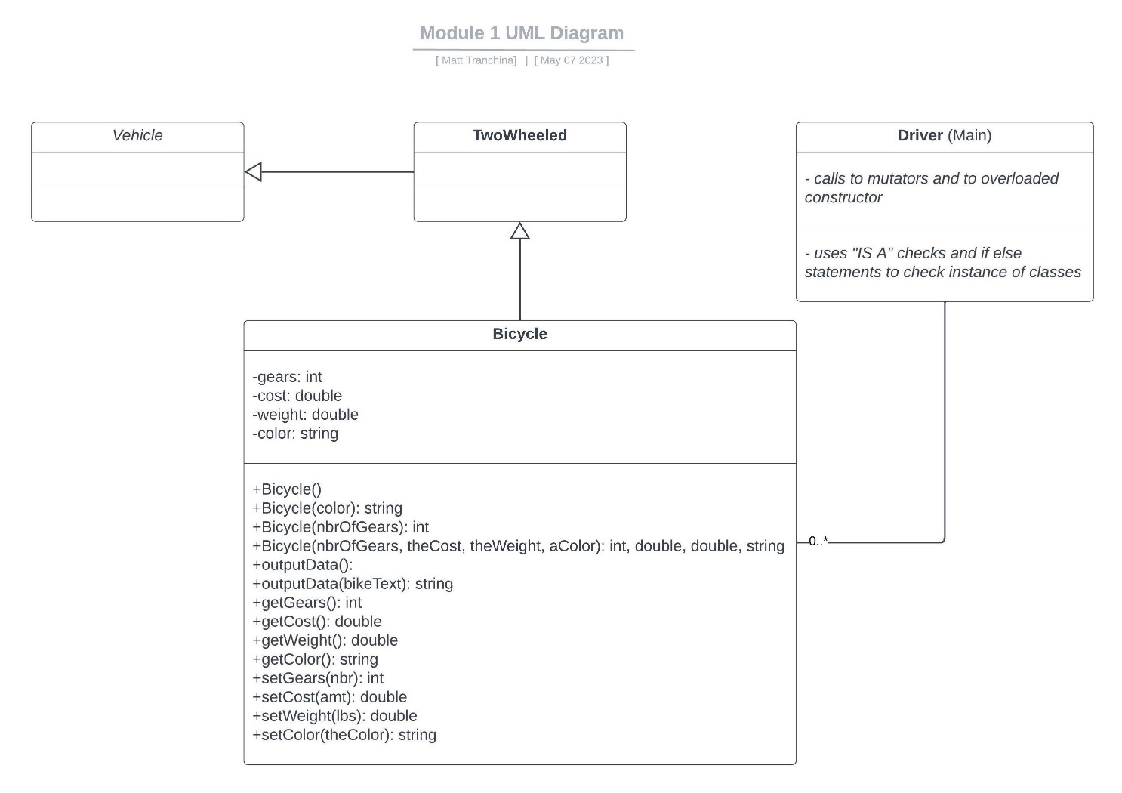

The above diagram illustrates 4 classes in an object-oriented program. The Driver class is the main class in which the user interacts. The Vehicle class is in which the other two classes, the TwoWheeled class and the Bicycle class, inherit traits. This means that although Vehicle currently has no traits, Bicycle would inherit Vehicles traits while adding its own. The attributes in Bicycle are set to private (-), meaning the number of gears, cost, weight, and the color can only be accessed by the bicycle class. The methods in Bicycle are public (+), meaning other classes like Driver can access methods like setColor or getCost.

The relationship between the Driver and other classes is an association, meaning other than working with and calling the other classes, they aren’t truly related. The multiplicity of 0..\* going into Bicycle means that there can be none or an unlimited amount of calls to that class and its parent classes.